Install terraform in the ubuntu 18.04

Steps To Install Terraform on Ubuntu 18.04 Server

### Step 01: update the system packages

# update the system packages with update command

**sudo apt-get update -y**

## **Step 2: Download Terraform package**

Downloads terraform with below command

**sudo wget** [**https://releases.hashicorp.com/terraform/0.12.18/terraform_0.12.18_linux_amd64.zip**](https://releases.hashicorp.com/terraform/0.12.18/terraform_0.12.18_linux_amd64.zip)

**Step 3: Unzip the terraform**

**sudo unzip terraform_0.12.18_linux_amd64.zip**

## **Step 4: Move terraform to bin folder**

move terraform executables to bin folder

**sudo mv terraform /usr/local/bin**

Now we have successfully installed terraform in ubuntu 18.04

## **Step 5: Verify Terraform Version**

verify terraform version with version command terraform -v

**# terraform -v Terraform v0.12.18**

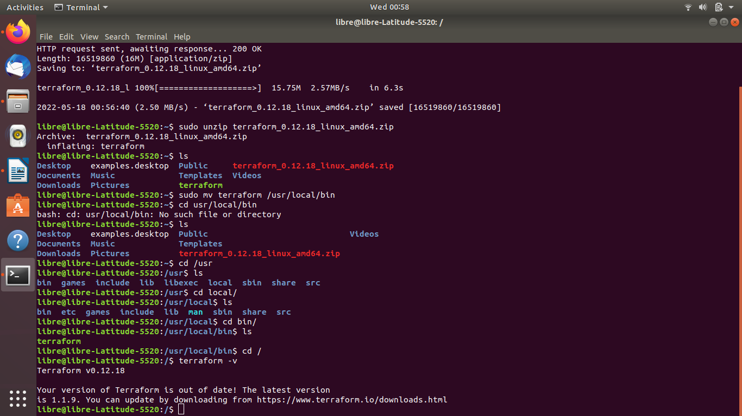

# Steps to create a EC2 instance on AWS using Terraform:

As everyone knows terraform is infrastructure as code tool so using terraform scripts or templates, we can deploy resources in aws or any other cloud. In this post we are going to see how to create or launch aws ec2 instance using terraform script or template.

**Steps 01: create a Directory for Terraform script:**

mkdir devops

cd /devops

pwd

/root/devops

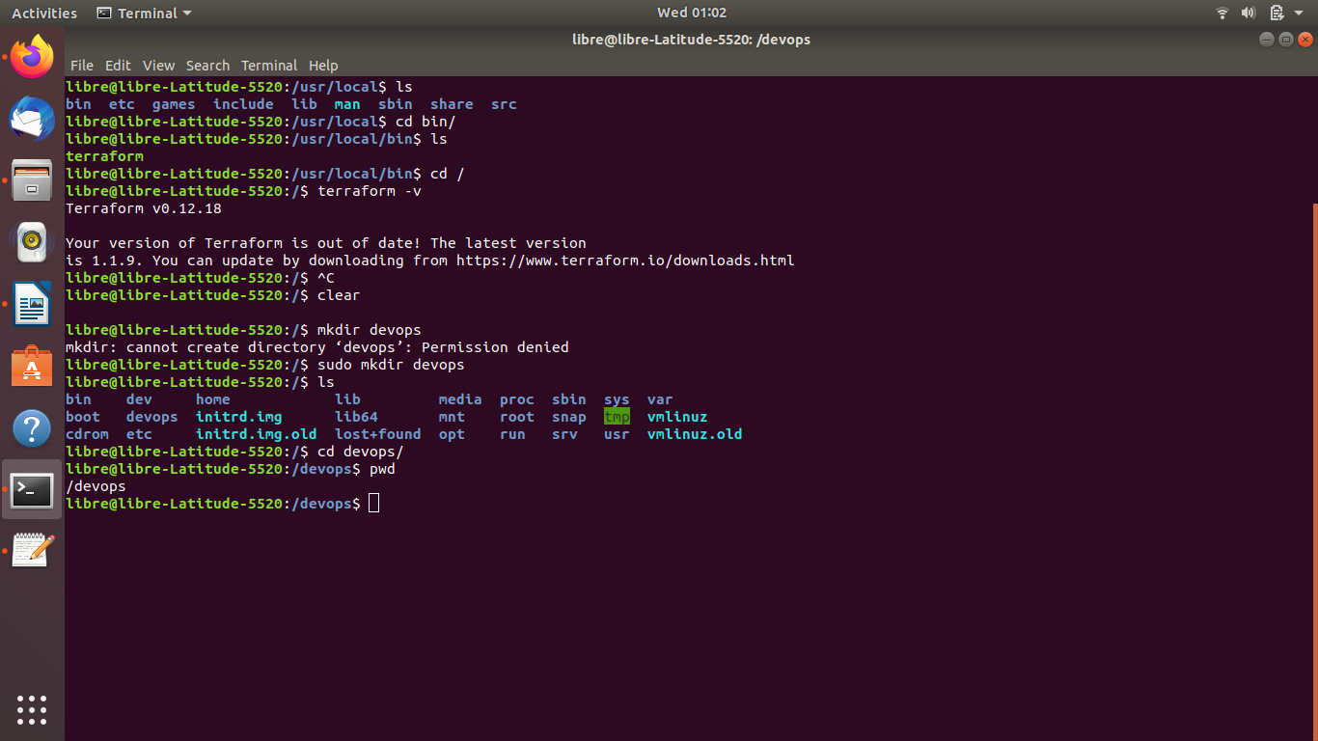

**Step2: Establish connection between the Terraform and EC2 instance on your AWS:**

Create a provider.tf in the /devops location

vi provider.tf

provider “aws” {

access_key = “XXXXXXXXXXXXXXXXXXXX”

secret_key = “XXXXXXXXXXXXXXXXXXXXXXXXXXXXXXXXXXXXXXXXX”

region = “us-east-1”

}

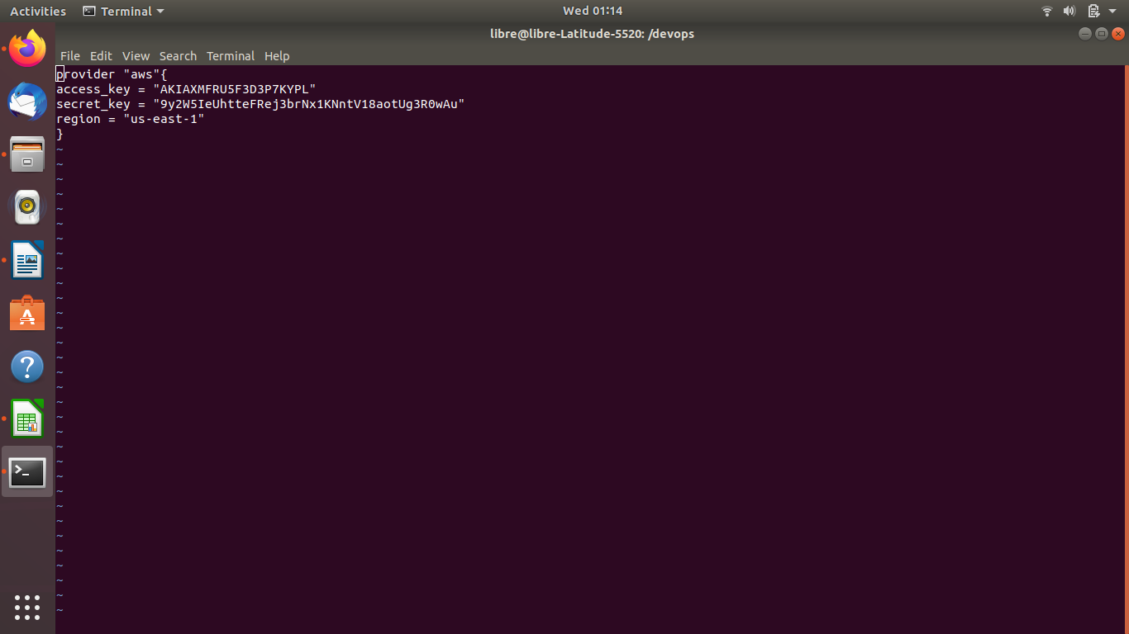

**Step 3: Initialize the terraform**

Execute **terraform init** command, it will download and install aws provider for you terraform scripts.

#terraform init

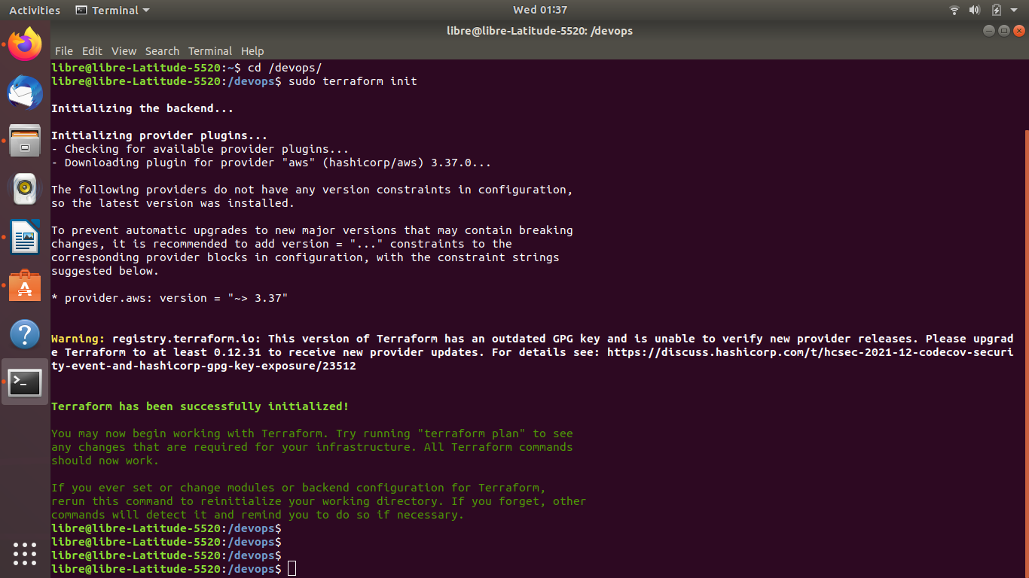

**Step4: create an EC2 instance using the terraform yaml** s**cript:**

To lunch or deploy ec2 instance in aws with terraform we must create aws ec2 terraform script. Here i created a terraform script to lunch aws ec2 instance and named it as ec2.tf. You can create the file with any name, but extension should be .tf only.

vi ec2.tf

resource “aws_instance” “web” {

ami = “ami-00068cd7555f543d5”

instance_type = “t2.micro”

tags = {

Name = “Hello to my first terraform script”

}

}

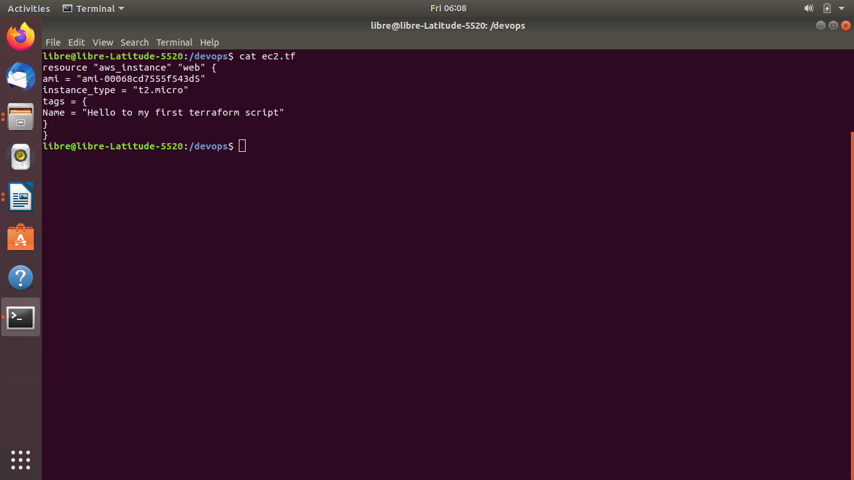

using this terraform template we can create aws ec2 instance in your aws account.

**Steps 05: Terrafrom Apply**

To create aws ec2 instance using terraform script we have we have to execute terraform apply command. This command will read your terraform scripts and it will create the resources whatever you mentioned in the terraform scipts. in above file you can see we mentioned only aws_instance so it will create only ec2 instance in aws.

if you enter the terraform apply command it will ask/prompt you to enter ‘yes’ to create reources in aws. if you enter yes, it will create aws ec2 instance.

terraform apply

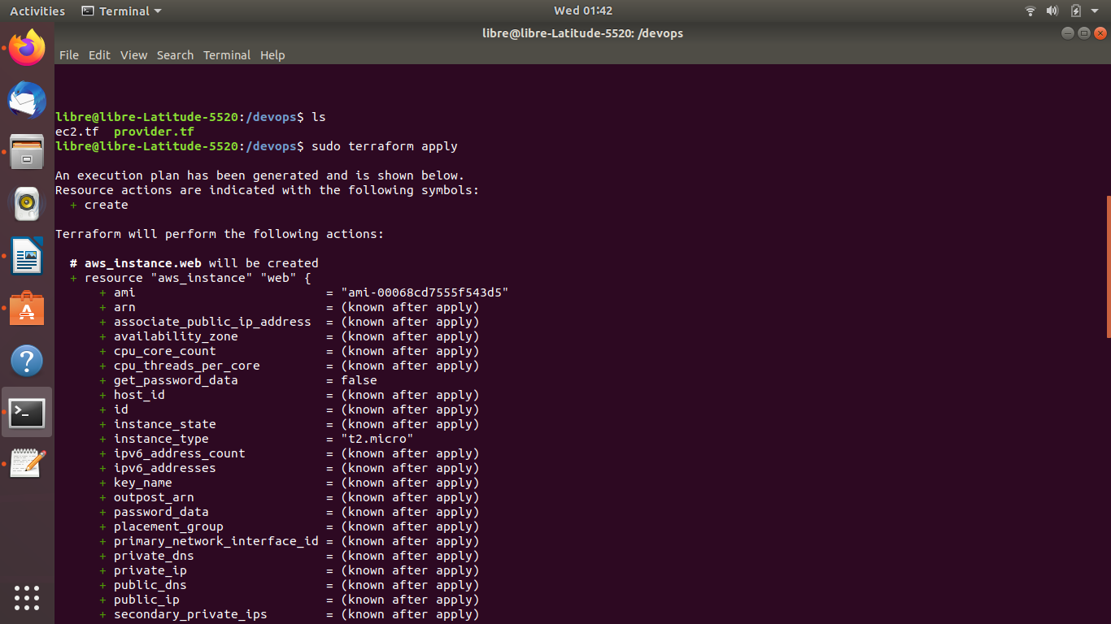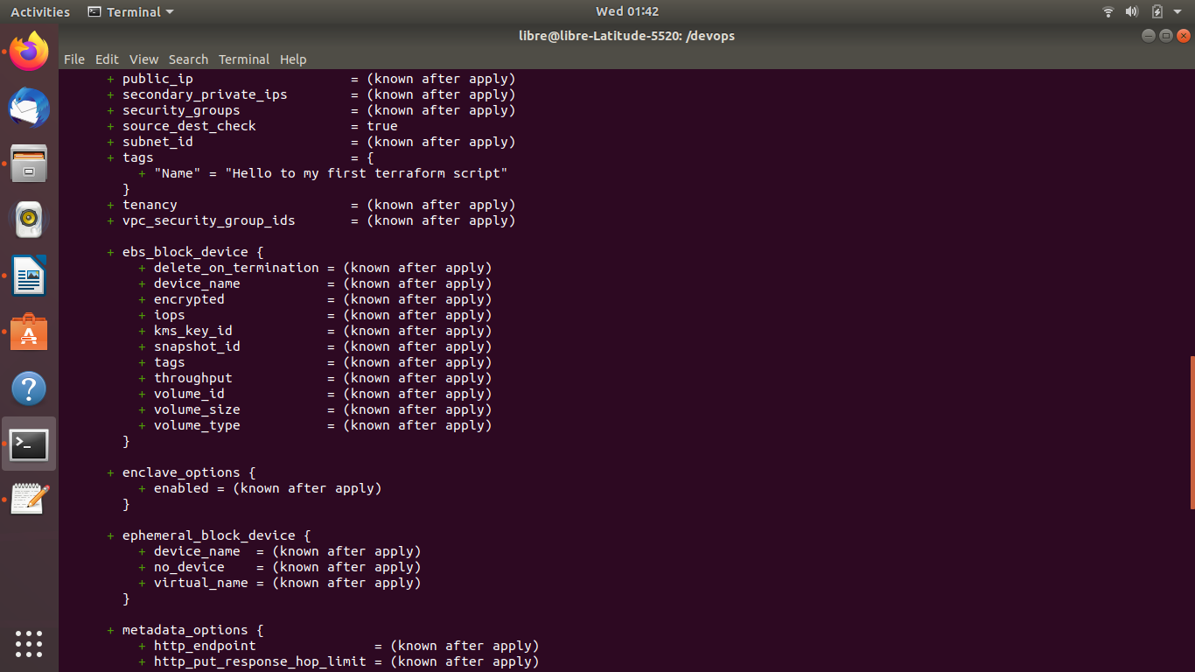

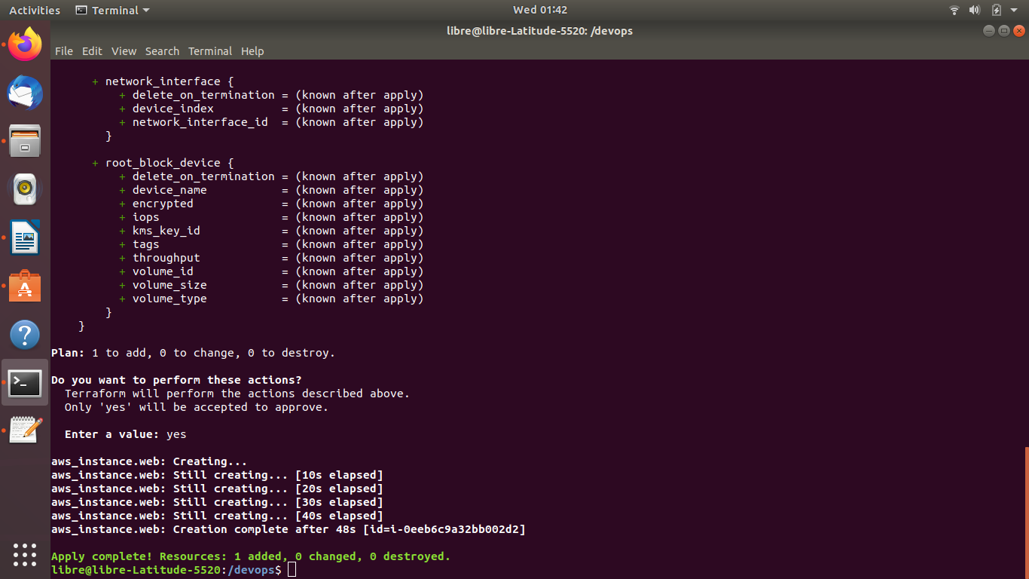

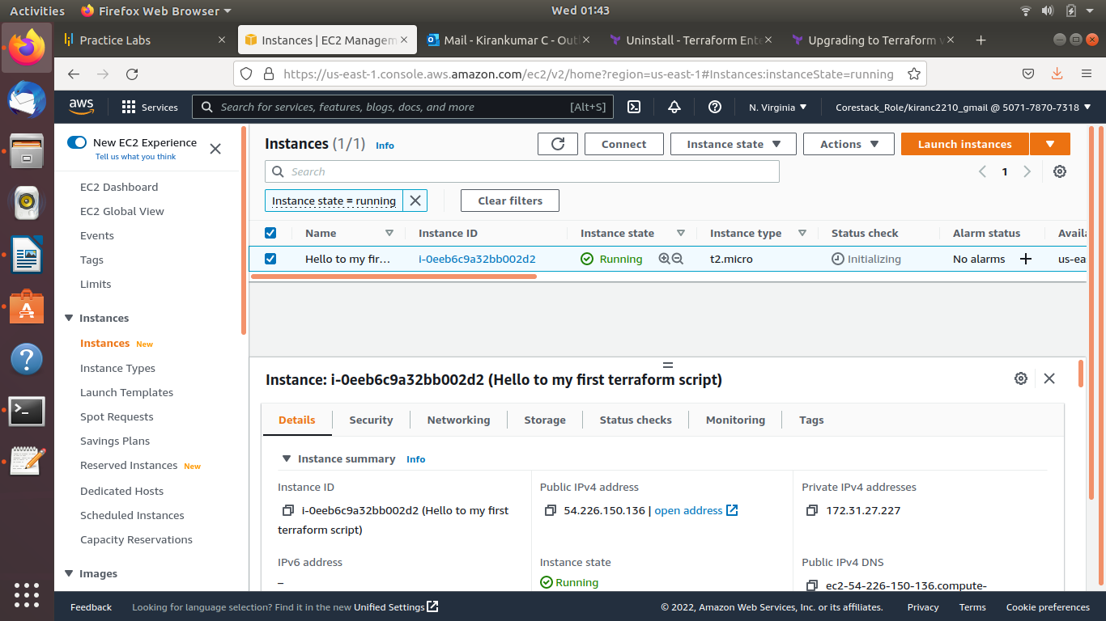

**step 06: after successfully create a EC2 instance in aws push .tf files to GitHub repository**

**cd devops**

**git status:**

**git add .**

**git commit -m ‘Create a EC2 instance using Terraform’**

**git push -u origin master**